Website updates – 2026-01-14
- Update Naturopathic Medicine Page
"C:\GIT Folder\JFB-KMT-SampleWeb\Issues\KMT_Naturopathy_Page_Copy.docx"

- Add a new page for IV Therapy:
"C:\GIT Folder\JFB-KMT-SampleWeb\Issues\KMT_IV_Therapy_Page_Copy.docx"
- Make the logo at the top be clickable to the homepage. 
- Remove In Oakville. We don’t want the site to be focused on only Oakville, but on the other locations as well. So please remove any site headlines or mentions that include only Oakville. Headlines should not mention a location. Basic content can include the mention of the different locations.


- Update naturopathic Medicine box based on the updated content for naturopathic medicine as well.
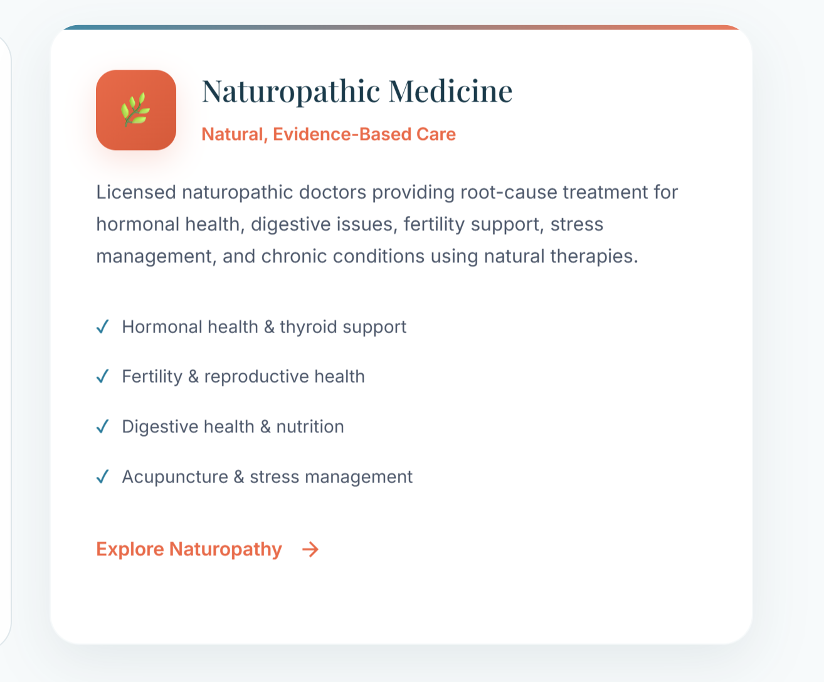
- Footer should include just the location names and clickable to the our Locations Page. I don’t like the boxes. And max it should have the name and address. Make it look sleek and nice. Figure something out for the white background on the logo.
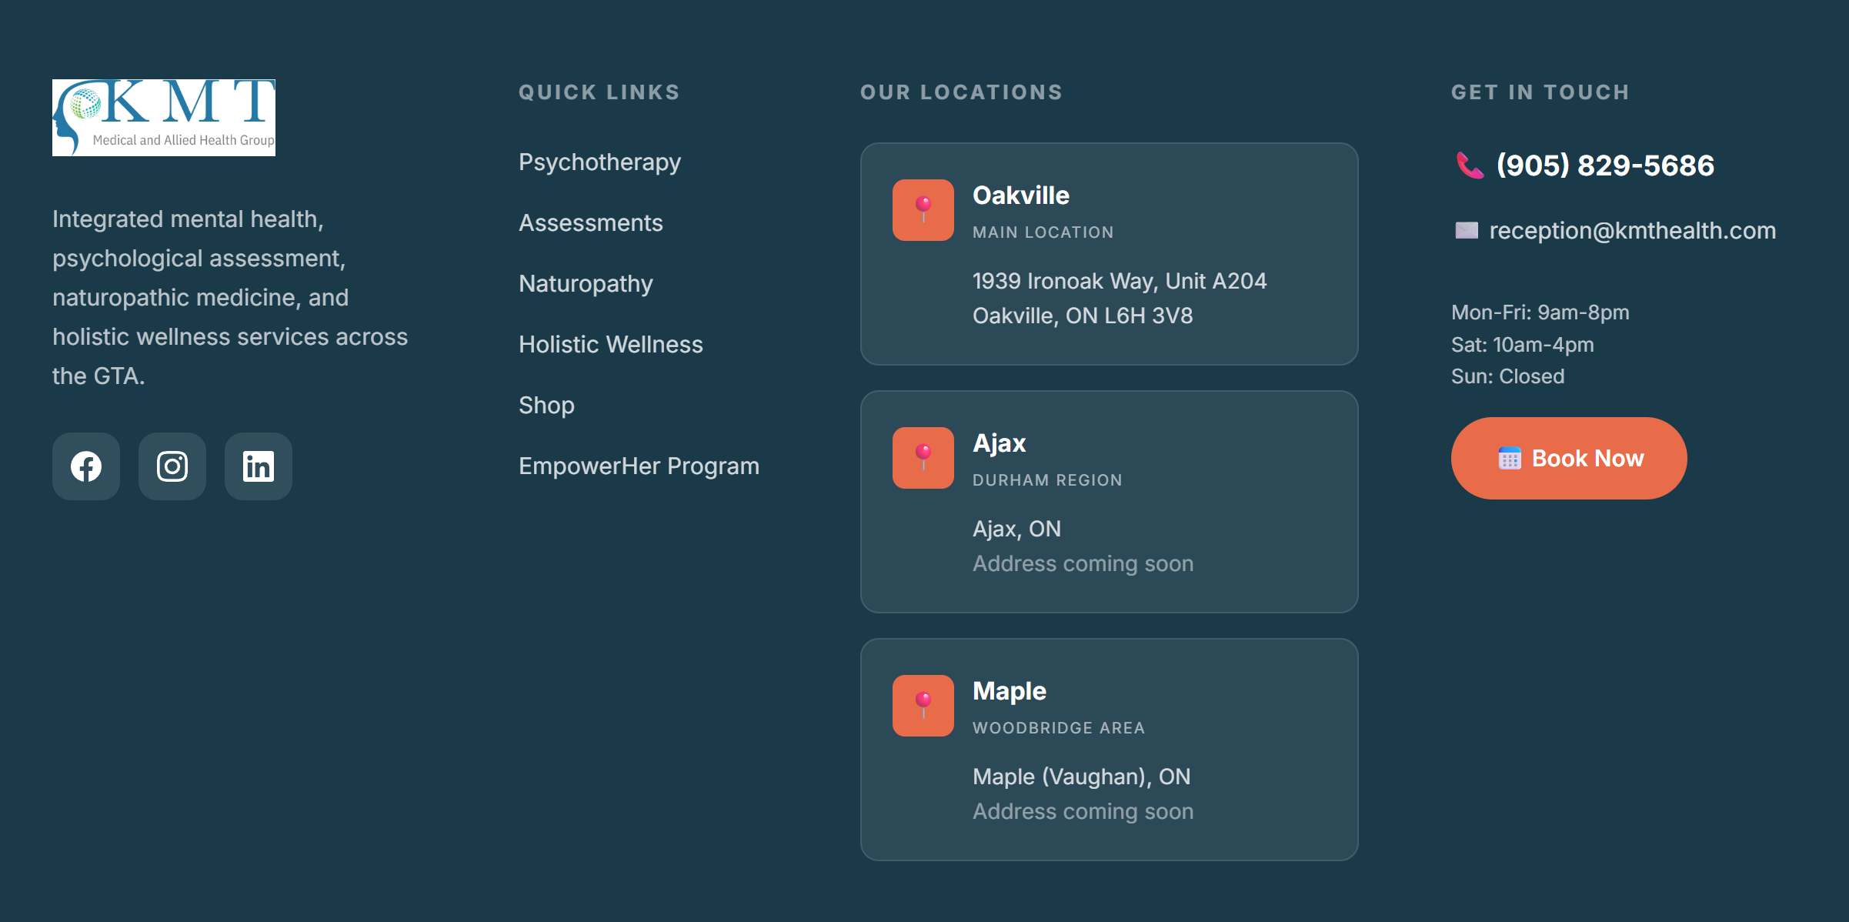
- Make a new Our locations page, featuring contact information and hours of each location.

- Book your appointment takes to a page similar to a team page, where it shows the portrait of the doctor, below the name of the doctor and the a book now button. Make this new page as the Book Now Page.
- Update the top nav menu with the items that have been created, make sure all links lead somewhere or be disabled if we don’t have content for them yet.

